# Sustainable technical solution EKTR

Our proposal for a sustainable technical solution is based on these prerequisites:

1. **Use open standards**  
   A registries purpose is to collect patient records from many sources over decades. These records are used for different research, studies and benchmarks purposes. To enable data collection, data sharing and staying up to date over a long period of time one should adhere to international standards.
2. **Shareable implementation model;** The international registry will exchange data with many national registries. For national authorities within the EU that do not have a registry, it should be possible to establish a national registry based on the international registries implementation.
3. **Predictable IT costs**The costs for the information technology falls down in two categories: Technical architecture (Software Licenses, Cloud solutions, technical support, security, analytics platform etc.) and Functional Support (Helpdesk, Data Management). To keep cost predictable and low you would ideally keep the costs for the technical architecture simple.

## Solution

For the European Kidney Transplant Registry (EKTR) the solution consists of 4 major components:

* OpenEHR platform and tools
* Data entry application (including batch file upload)
* An analytics platform
* Cloud servers and databases

**OpenEHR platform**'openEHR' is the name of a technology for e-health, consisting of open specifications, clinical models and software that can be used to create standards, and build information and interoperability solutions for healthcare. The various artefacts of openEHR are produced by the openEHR community and managed by openEHR International, an international non-profit organisation originally established in 2003 and previously managed by the openEHR Foundation.1

Their are several openEHR clinical data repository (CDR) implementations available by both commercial vendors as opensource solution providers. For this project after a market comparison the platform from Better.care (commercial vendor) was choosen. Besides the openEHR platform, Clinical Models, openEHR API, it has a suit of tools that makes working openEHR models and databases easier. This includes a way to Transfer data with an ETL tool (Extract Transfer Load) from the openEHR database tot he analytics platform.

As openEHR promotes open Clinical Models, all models we created during the project are shared on our GitHub and can be reused to design data models for registries, or can be used in any openEHR platform to instantly create a Clinical Data Repository that fullfills that standards from the EKTR.

Based on the models countries that do not have an established national registry can deploy their own openEHR platform. By deploying the edith clinical models on the platform they can easily exchange data with the international registry, while having the flexibility to extend the models when needed.

**Data Entry application**

The data entry application can be used for manual data entry and consists of Forms for both Initial follow-up and recurrent yearly follow-up entry. It also features a batch upload for uploading bulk (CSV) files with data. It is based on the Pathfinder application provided by Better.care.

**Analytics platform**

From the openEHR platform data is transferred to a separate analytics database (with help of the ETL tooling). This can be any analytics platform but because of the modest requirements we currently need for the project Metabase is our platform of choice. It provides downloads in several formats and a lightweight anaylics dashboard.

**Cloud servers**

A test and production environment of the software solution stack are running on a AWS (Amazon) Cloud server. Maintenance and installation is done by a consulting partner.

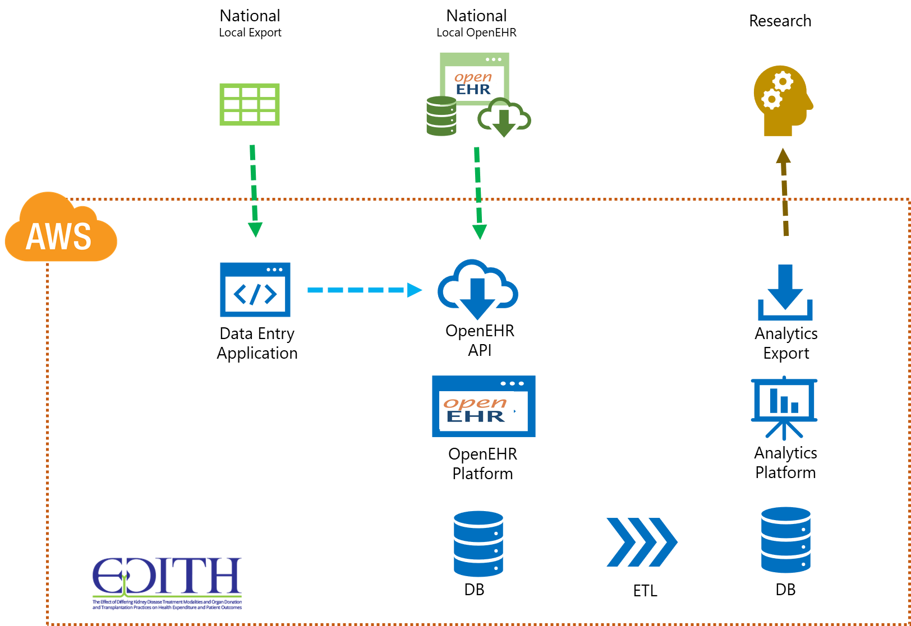

Figure 1 EKTR solution setup

**Proposed sustainable solution**

Our proposed solution is a mix for two different scenarios:

1. An adapted scenario based on OpenEHR platform of Better.care
2. An opensource based solution on Ethernet or EHRBase

**OpenEHR platform commercial vendor (Better)**

In our experience the current setup should be slightly altered to be a sustainable solution. The cost of installation and maintenance on the AWS platform can be mitigated by using the Software as a Service solution that Better offers. It has a pay by patient license so it can linearly scale from a modest registry in the starting phase to a 300.000 patient record holding full size European registry needs.

Also we would not use the front-end application at the international registry, it is expensive and would not be used by any of the countries with established registries (as we experienced in the pilot phase). However the forms produced can be used in national registries if needed on their own openEHR platform.

Such a platform can be supported by a data manager and/or helpdesk employee for support of the systems. Technical maintenance and installation costs would be minimal (only for the analystics platform) as the openEHR platform will be taken care of under the Software as a Service license.

**An opensource based solution on Ethernet or EHRBase**

We could also use an opensource HER platform. This would have considerably higher upfront costs for installation and new tools should be found for e.a. ETL. Also to be able to have feature in an open source platform one should invest in having some development time available to contribute to the open source project. Where in the first scenario one would mainly need a Helpdesk and Datamangement capacity, in this case we would need more technical support, development capacity in the EDITH organisation.

It does have the benefit that after initial costs, the running costs are lower because there is no license fee.

## Costs

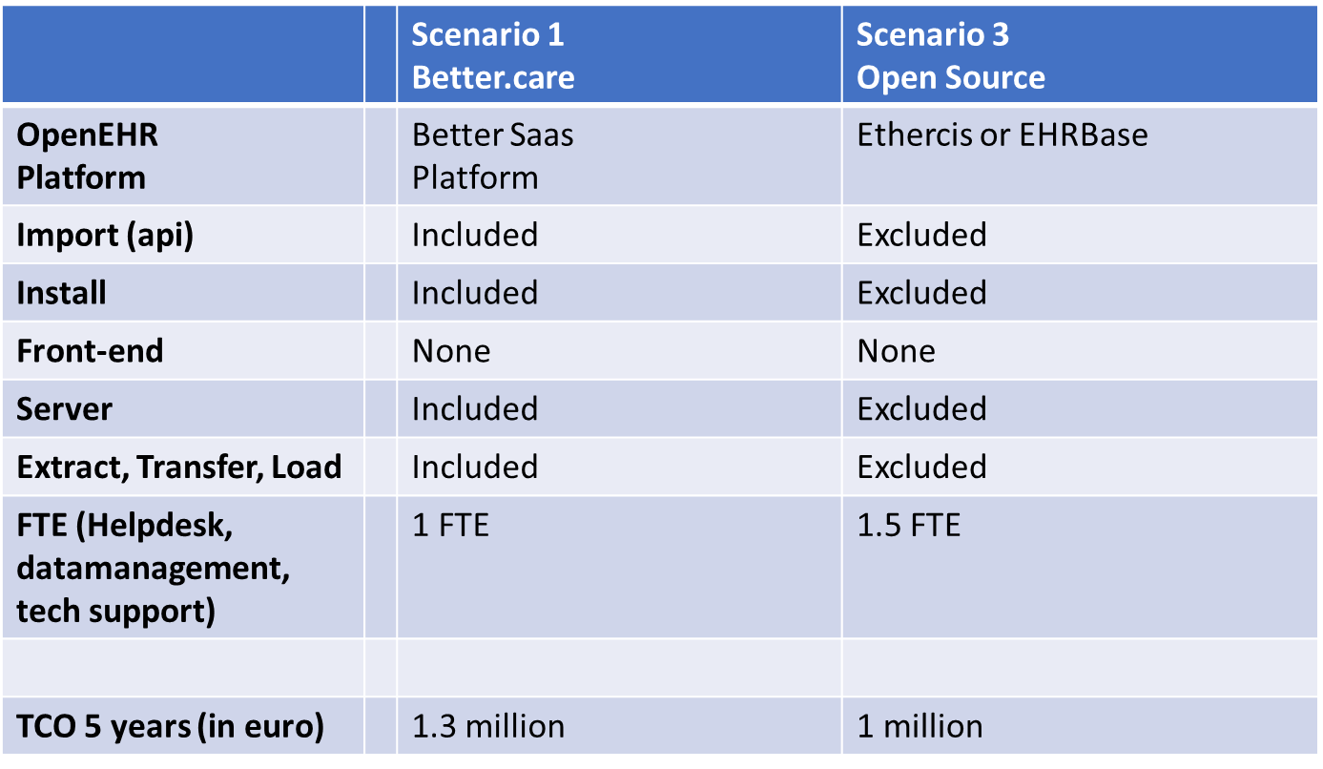

Figure 2The two scenarios compared

**Scenario Better Platform**

The cost for t he Better platform scenario are based on 1 fte for Helpdesk and Datamanagement and the Better license fee fort heir SAAS platform. The total cost of ownership (5 years): approx. 1.3 million euro build up over the years:

* + Year one (25% patients): 140.000
  + Year two (75% patients): 250.000
  + Year 3 and further (100%): 305.000

Risk is in this scenario reasonably low as the main component is supported by a commercial party and contract. Also no applications need tob e build.

**Scenario Open Source**

An opensource solutions needs about 1.5 FTE for helpdesk datamanagement and technical support. Also costs need to be reserved for installation and software development in year 1.

The cost for Total cost of ownerwhip 5 year: approx 1 million euro

* + Year one: 320.000 euro
  + Per year after: 170.000 euro

Risk is considerably higher because the exact costs for installation and addtional tools are unknow. Support is based on an open source community, which might be a risk depending on how active the community is.

**Recommendation**

We recommend that one would start the first years with the Better platform. When the platform is not used to its full capacity the Marand platform has a lower cost of ownership (till about 50% use), Risks are lower in the crucial first years of the registry and the registry can be established quickly based on the current registry.

After the registry is well established the risk and the startup costs of an open source openEHR CDR can be wait against the commercial openEHR CDR again.